[**2. Junit Advanced Testing Outputs**](blob:https://github.com/85182277-c94f-4e35-8da5-034d6cabca73)

**Exercise 1: Parameterized Tests**

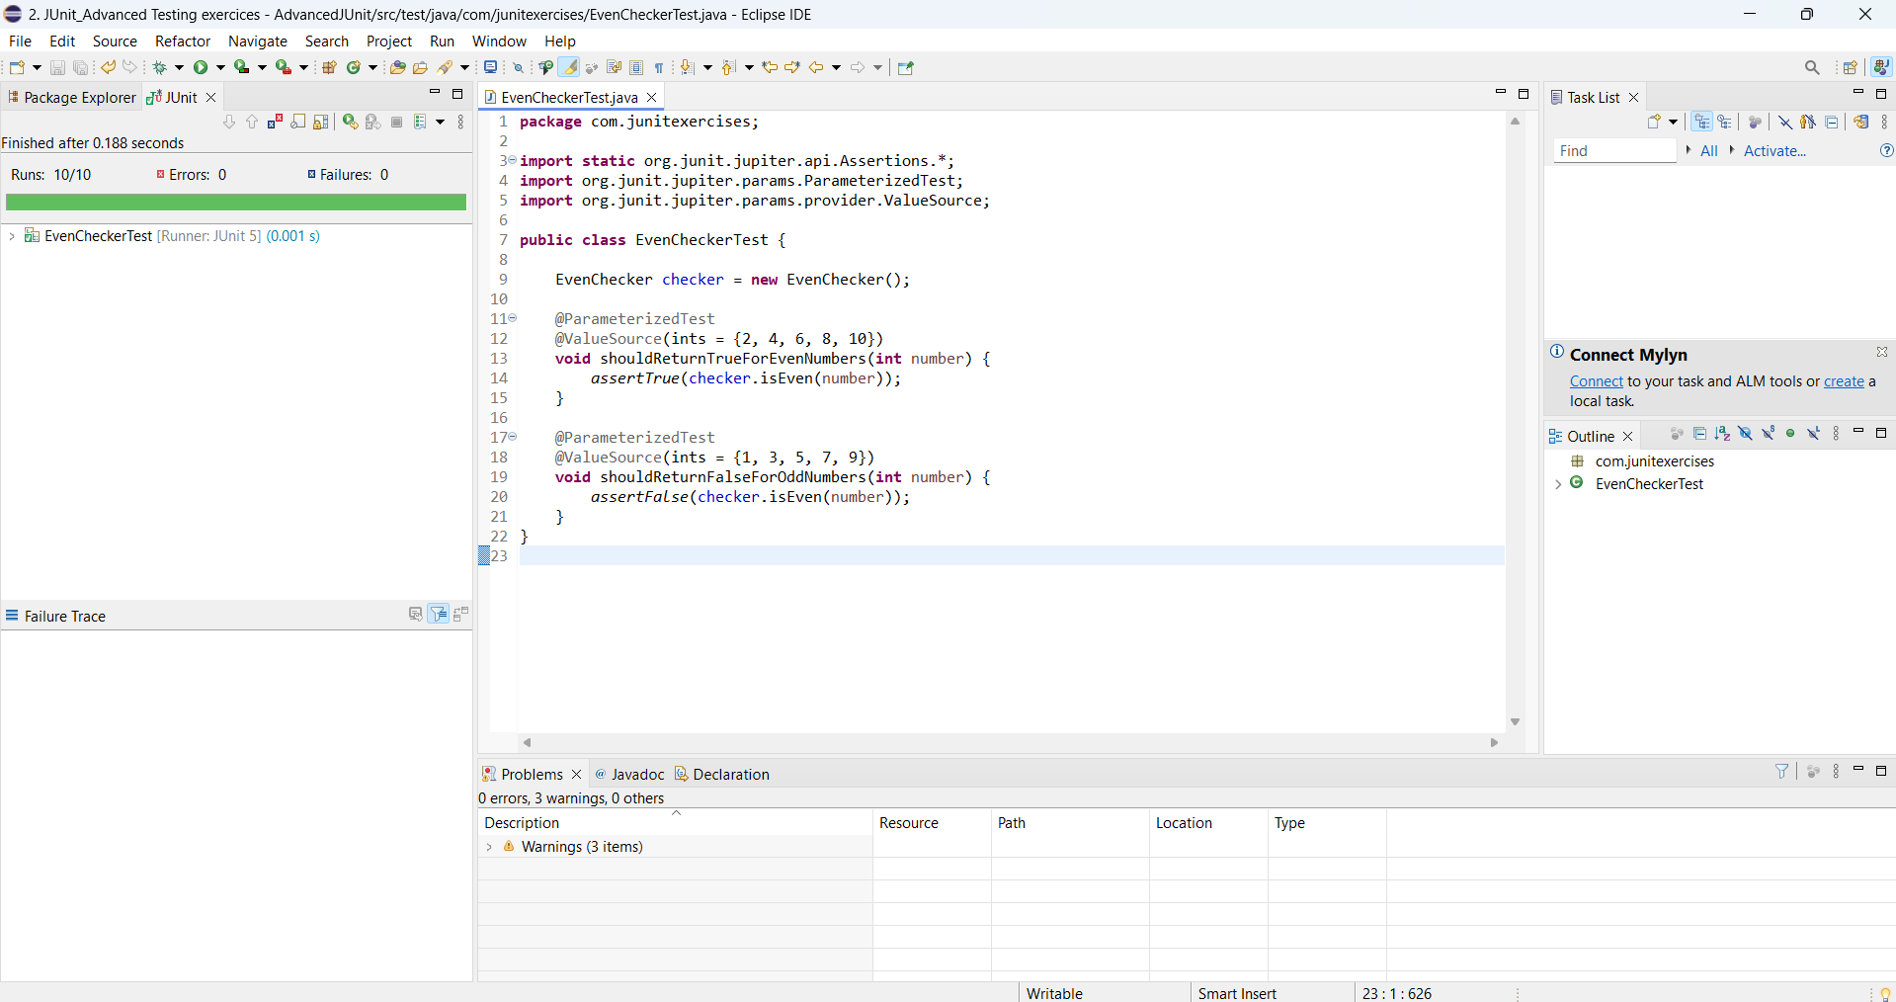

**Exercise 2: Test Suites and Categories**

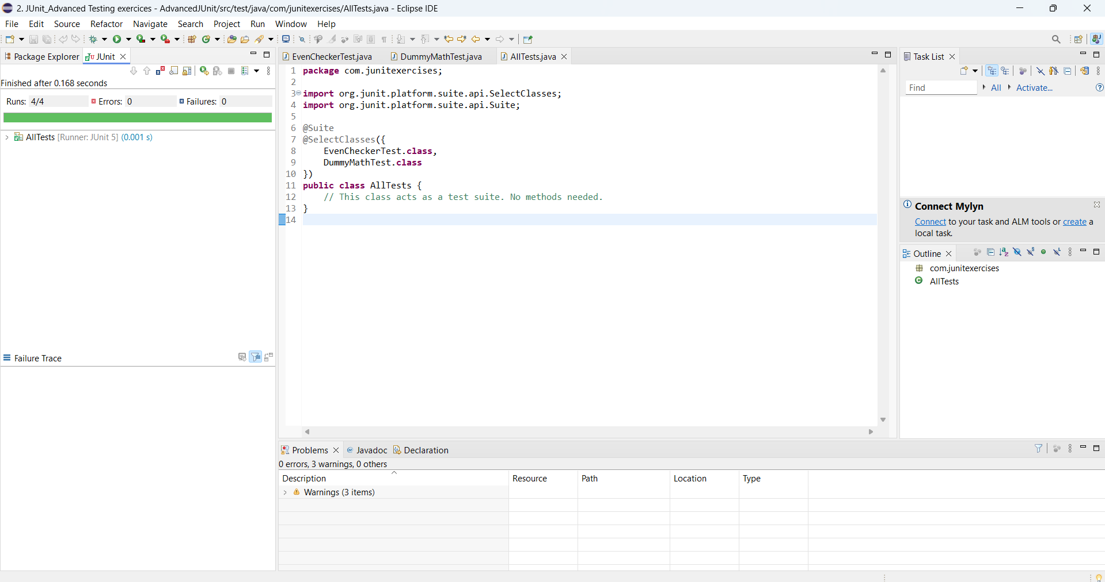

**Exercise 3: Test Execution Order**

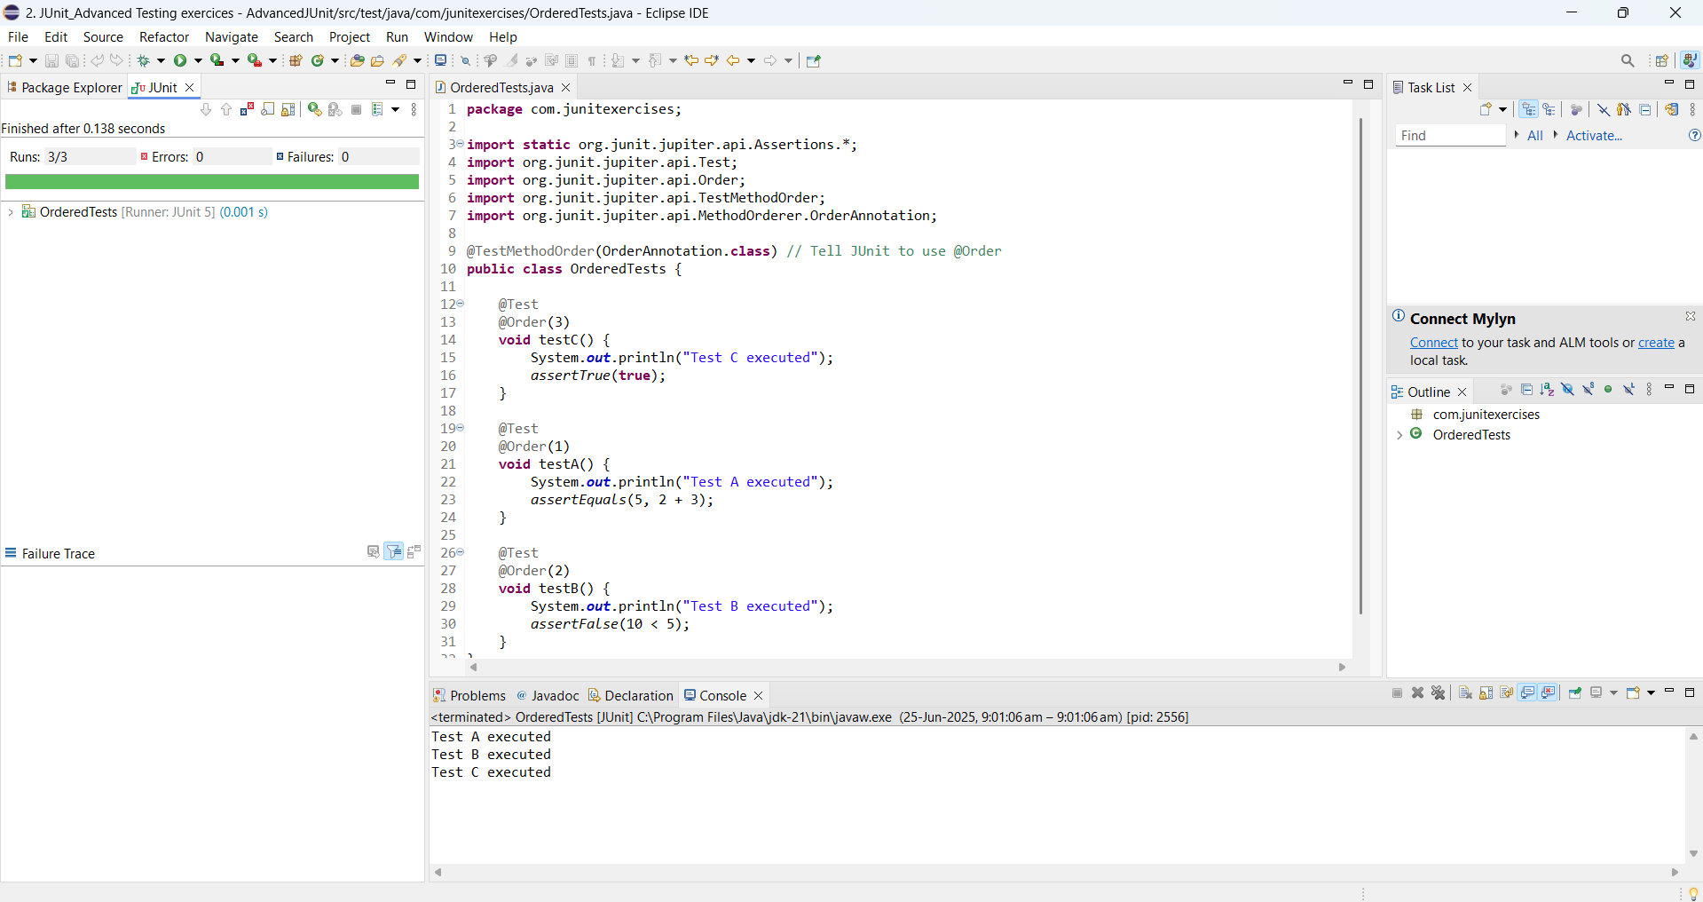

**Exercise 4: Exception Testing**

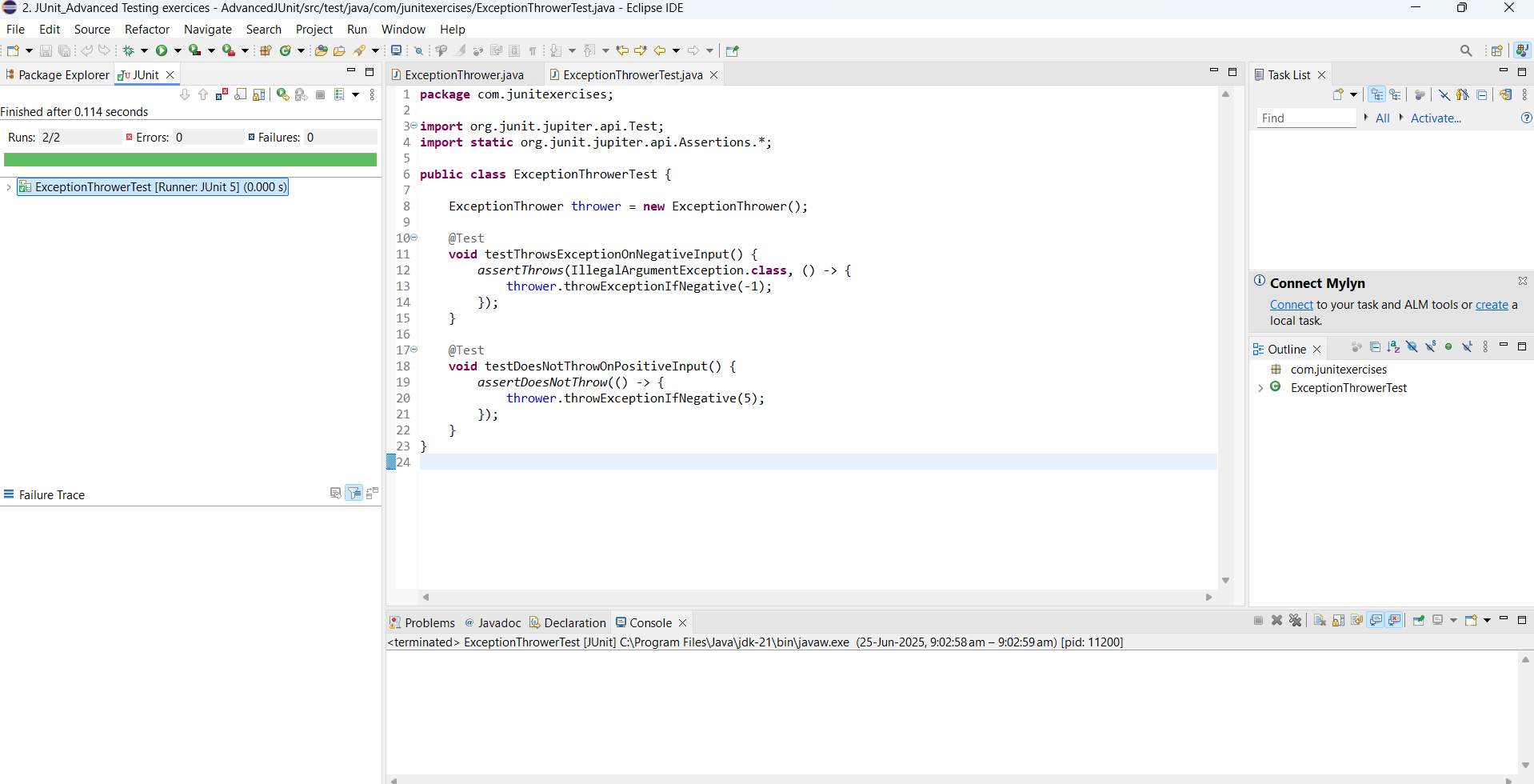

**Exercise 5: Timeout and Performance Testing**

